|  |  |
| --- | --- |
| **Name:** | Bodhisatya Ghosh |
| **Branch:** | CSE – Data Science |
| **Batch:** | B |
| **Course:** | Soft Computing |
| **Experiment no:** | 5 |

**Aim:** To implement a CNN for a given problem statement.

**Theory:** A **Convolutional Neural Network (CNN)** is a type of Deep Learning neural network architecture commonly used in Computer Vision. Computer vision is a field of Artificial Intelligence that enables a computer to understand and interpret the image or visual data. Convolutional Neural Network (CNN) is the extended version of [artificial neural networks (ANN)](https://www.geeksforgeeks.org/artificial-neural-networks-and-its-applications/) which is predominantly used to extract the feature from the grid-like matrix dataset. For example visual datasets like images or videos where data patterns play an extensive role.

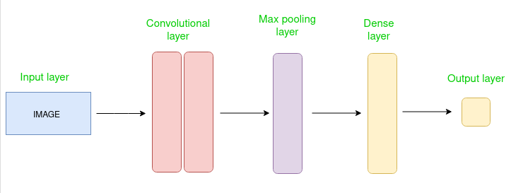

The Convolutional layer applies filters to the input image to extract features, the Pooling layer down samples the image to reduce computation, and the fully connected layer makes the final prediction. The network learns the optimal filters through backpropagation and gradient descent.

**Program:** 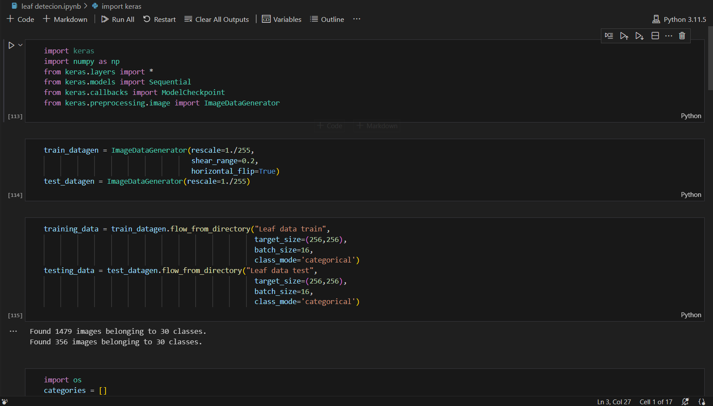

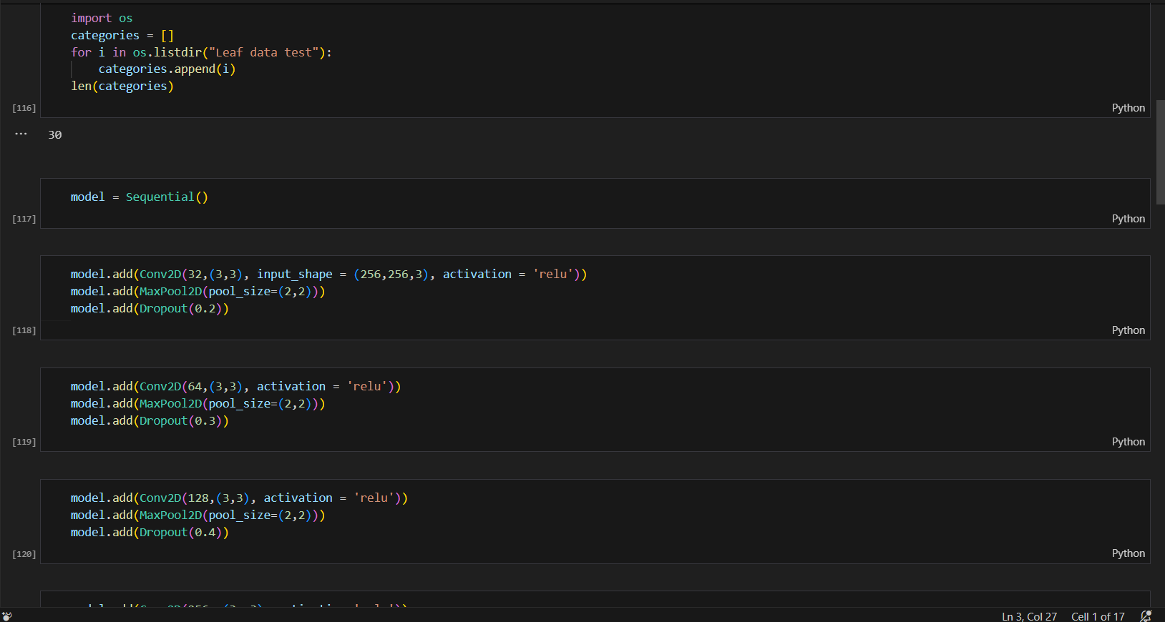

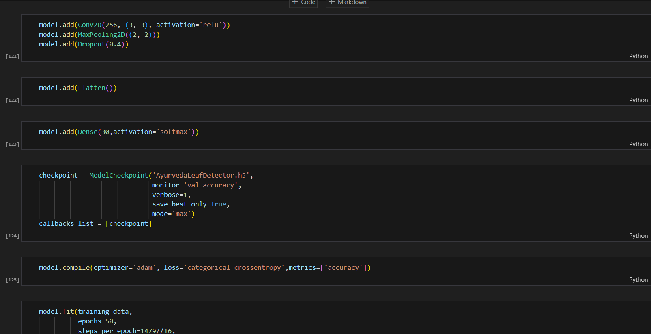

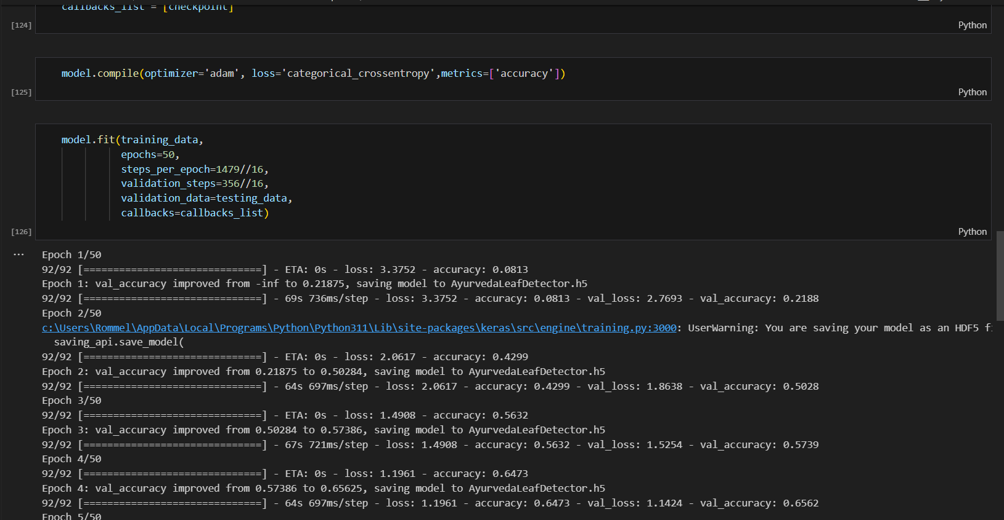

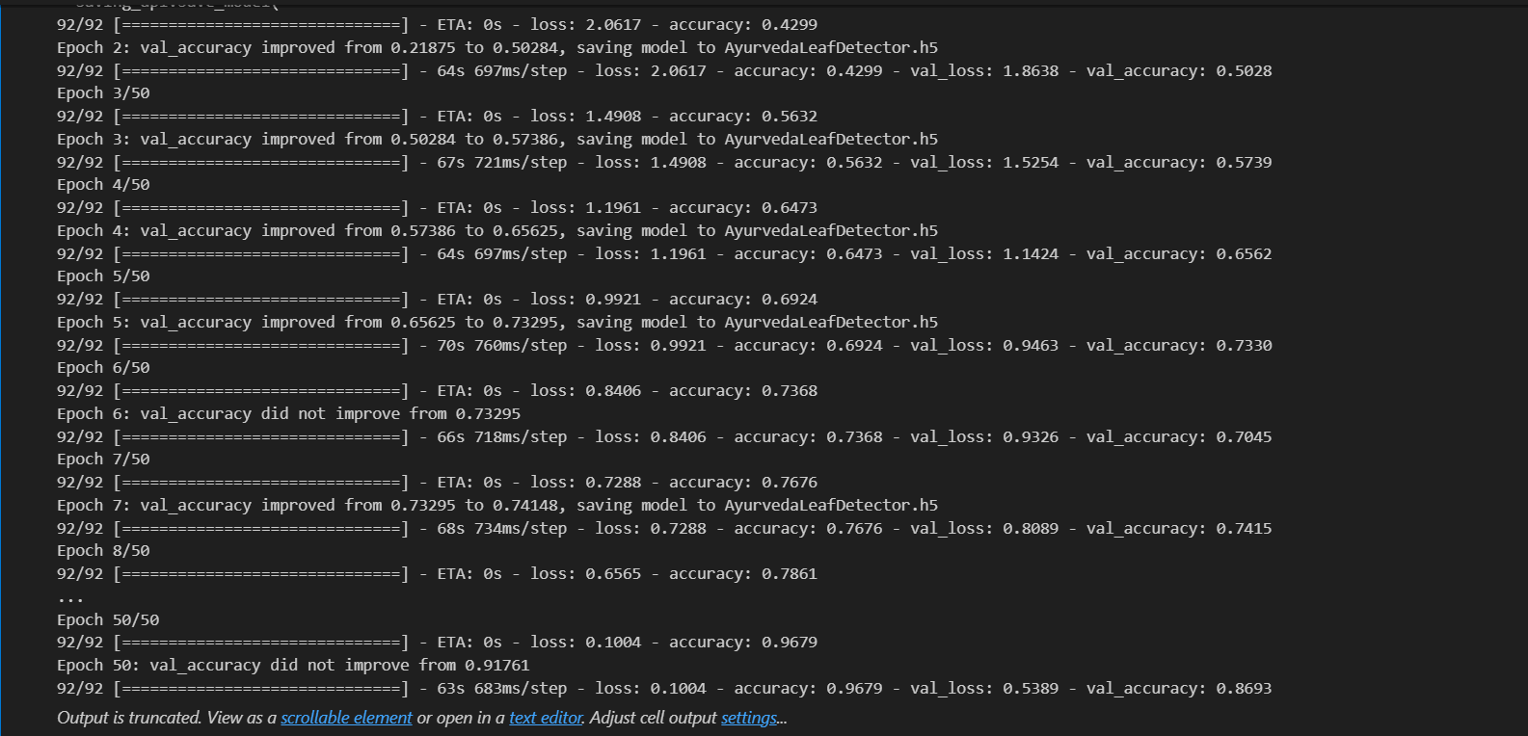

**Results:**

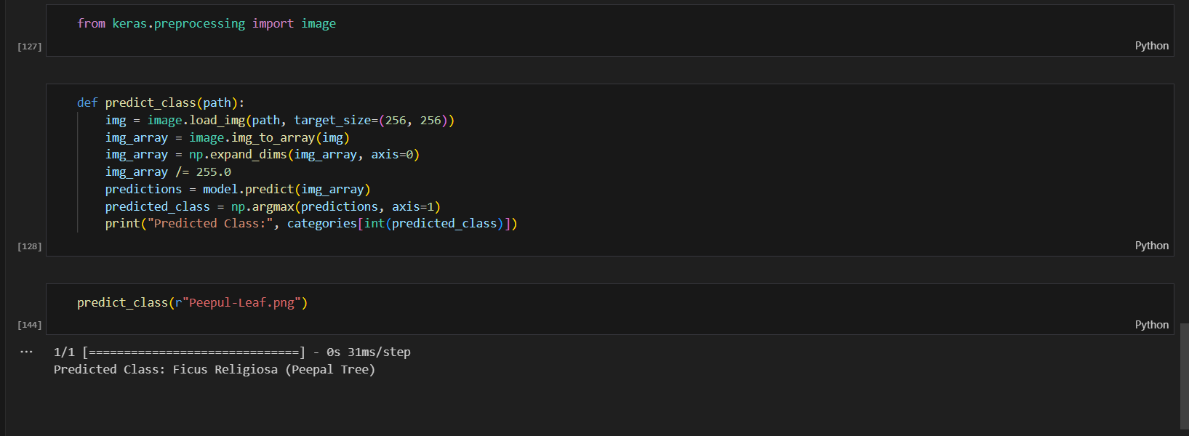

**CONCLUSION: -** In this experiment we studied about unsupervised learning using Kohonen Self-Organising Feature Maps